OCTOBER 1, 2013: Health Insurance Exchanges Open

ACA Overview and Refresher

The key provisions of the Affordable Care Act (“ACA”) are slated to go into effect this week. On Tuesday, October 1, states and the U.S. Department of Health and Human Services (“HHS”) will open their Health Insurance Exchanges, otherwise known as “Marketplaces.” The Marketplaces will exist online and, if they operate as intended, provide a central site at which individuals and small groups will be able to compare and purchase health insurance plans. As of this writing, however, the Maryland and DC state Exchanges are not fully operational, and many applicants have not been able to open an account on the federally-facilitated Exchange.

The Exchanges are at the center of the structural overhaul of the health insurance market. Issuers can reach consumers at these one-stop Marketplaces and offer a range of plans covering an essential health benefits package at different value tiers. These Marketplaces provide a competitive, structured venue for insurance transactions that, if they prove popular and efficient, could result in a dramatic evolution in how Americans access health insurance coverage.

However, the technical expertise required to run a Marketplace online is proving very challenging for many states and HHS. Over 30 states have elected or defaulted to a federally-run or “partnership” Exchange in which HHS will have significant operational and legal responsibility over the state activity. Only 18 states will run their own Exchange in 2014. In the first hours of their debut on October 1, both HHS and state Exchanges experienced significant technical difficulties, rendering the Exchanges at least temporarily inaccessible. This experience was not unexpected with the implementation of a federal/state program as massive as the ACA. HHS has delayed the online opening of the federal Exchange for small groups, which is now slated to open online on November 1. However, by the end of the first day of open enrollment, HHS had recorded over 2.8 million visits to the ACA website.

In addition, the ACA has become no less politically polarizing since it was enacted in March of 2010, and many state leaders are reticent to embrace the reforms. Indeed, politics over health care reform continues to occupy the attention of conservatives at the national level, and on October 1, Congress allowed the federal government to shut down over disagreements on whether the ACA should continue to be implemented.

Coverage purchased on the Exchange by individuals and small groups before December 15 will become effective on January 1, 2014. This is the effective date of the individual mandate, the ACA requirement that every individual obtain health insurance coverage or pay a fine for not doing so. The initial enrollment period for private coverage will occur from October 1 through March 30, 2014. After the initial enrollment period, individual plans will have annual enrollment periods. Small employer exchanges (commonly known as “SHOP” Exchanges) will have ongoing enrollment periods. For those states that choose to expand their Medicaid programs, enrollees will be able to access Medicaid through ongoing enrollment periods.

Beginning in 2015, the employer “mandate” takes effect. This means that any employer with more than 50 full-time equivalent employees will be fined if it fails to offer affordable coverage to employees who then go to an Exchange and receive a federal subsidy to purchase individual coverage. This employer penalty is known as the employer mandate although employers are not technically mandated to provide health insurance coverage.

The next few months will determine whether the Exchanges take hold and provide a sustainable, and trusted venue for Americans and small businesses to purchase—and insurance companies to sell—health insurance. Whether individuals who are currently uninsured, including young, healthy adults will use the Exchanges; whether small employers will use the Exchanges; whether large employers will stop offering insurance and instead expect employees to purchase insurance through the Exchanges; whether more states will expand Medicaid next year—all of these variables will have an impact on the success of the new Marketplaces.

Provisions of the ACA in effect prior to October 1:

- Prohibition on pre-existing condition denials for children under 19 years of age
- Young adults can choose to stay on parents’ insurance plans up to age 26
- Health insurance plans are prohibited from placing lifetime monetary caps on essential health benefits (105 million Americans have had life time caps on health insurance eliminated by this provision)
- Annual caps in benefits are being phased out
- Consumers receive premium rebates if their insurer fails to spend 80% of premium revenue on health care (more than $1.3 billion in rebates either were paid in 2012 or will be paid in 2013 under this provision)
- Private health insurance plans cover preventive care with no cost-sharing for the participant
- Seniors covered by Medicare receive a $250 rebate to reduce the prescription drug “donut hole” or coverage gap
- Small businesses (fewer than 25 employees) receive a tax credit of up to 35% of the employer’s contribution to the employees’ health insurance

Provisions of the ACA that take effect on October 1 (for plans effective January 1, 2014):

- Pre-existing condition exclusions are prohibited
- Health insurance plans cannot set premiums based on health status
- Health insurance plans must guarantee issue of health insurance coverage
- Health insurance plans cannot rescind coverage for reasons other than non-payment of premiums
- Annual caps in benefits are completely prohibited (phase out is complete)

Provisions of the ACA that are delayed until after the January 1, 2014 start date for market reforms:

- Fines delayed until 2015 for large employers who fail to offer affordable health insurance coverage to employees who receive a federal subsidy to purchase coverage on an Exchange
- Small employer choice to offer a range of plans to employees delayed until 2015 on the federally-facilitated exchange (“FFE”) and for some state Exchanges
- Nationwide Medicaid expansion as written into the ACA delayed indefinitely by the Supreme Court’s decision to make expansion a choice by individual states, so that almost half of the states will not expand Medicaid as of January 1, 2014.

Application submission date | Guaranteed effective date of coverage
October 1 through December 15, 2013 | January 1, 2014
December 16 through January 15, 2014 | February 1, 2014
January 16 through February 15, 2014 | March 1, 2014
February 16 through March 15, 2014 | April 1, 2014
March 15 through March 31, 2014 | May 1, 2014

Purchasing Health Insurance on Exchanges

All legal constituents of a state can utilize their Marketplace, even if they currently have insurance. Individuals eligible for Medicaid under the new rules will also be able to apply through the Marketplaces as they are intended to be one-stop access point for coverage. Small employers can select and purchase a plan for their employees, and in some states they can select a range of plans from which their employees can choose. Each state has its own Marketplace, although in many states the Exchange is run by the federal government. On or after October 1, 2013, www.healthcare.gov will serve as the portal to all state marketplaces.

In states utilizing the federally-facilitated exchange (“FFE”) to run their Marketplace, individuals and small employers can purchase directly from this site. In states operating their Exchange independent of the FFE, individuals and small employers can use that website to access their state’s Marketplace, or go to the site for their state’s Exchange directly. The online Marketplaces will request from the users some basic information, such as the user’s income and preferred type of insurance coverage, and then display suitable plan options along with basic information detailing the plans’ benefits and costs.

The marketplaces will offer five different categories of insurance plans: catastrophic, bronze, silver, gold, and platinum. Catastrophic plans have low premiums, high cost-sharing, and are available only to those under the age of 30 who cannot find affordable insurance coverage elsewhere. Bronze, silver, gold, and platinum plans cover 60%, 70%, 80%, and 90% of the cost of care, respectively. Bronze tier coverage will have the lowest premiums and platinum tier coverage will have the highest premiums. All of the plans cover the ten essential health benefits required by the ACA, described below.

In addition to creating marketplaces to facilitate the sale of competitive insurance plans, the ACA provides premium subsidies for individuals who cannot otherwise afford coverage; those earning between 100% and 400% of the federal poverty level (“FPL”). These subsidies will vary in value depending on where the individual’s income falls within these limits. For those earning between 100%-250% of the FPL, subsidies for deductibles and copayments will also be available.
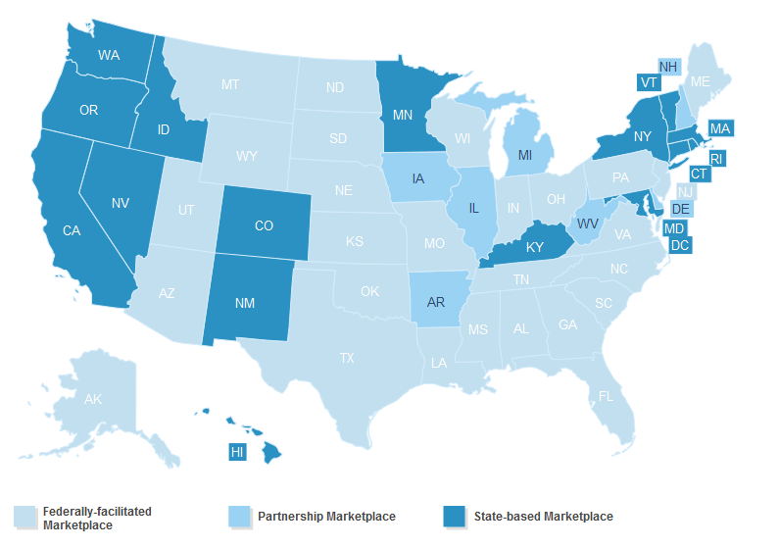
17 State Exchanges; 34 Marketplaces Operating through FFE, with 7 in a managing partnership with HHS
Table Courtesy of Kaiser Family Foundation
Small Employer Exchanges

The ACA provides for the creation of health insurance marketplaces exclusively for small businesses, otherwise known as the Small Business Health Options Program (“SHOP”). For most states operating their individual market exchanges through the FFE, HHS will run both a SHOP and individual marketplace. States that run their own marketplaces have the option of opening the two markets separately, or integrating them into one. Throughout 2014, the SHOP marketplaces will be available to all businesses with fewer than 50 employees. Beginning in January 2015, the market will open for businesses with as many as 100 employees.

Some features of the SHOP Exchanges will be operational on October 1, 2013. The federal SHOP marketplace website will not be online until November. During the month of October, businesses can apply via paper application or by telephone. As the SHOPs were originally conceived, an employer could specify a metal tier— bronze, silver, gold, or platinum—and their employees could choose from a range of plans on that tier. But for 2014, FFE SHOP marketplaces will have employers select a specific plan, much the same way employers sponsor insurance today. States which run their own Exchanges have the option of implementing the multi-option SHOP marketplaces in 2014.

The SHOP enrollment period is year round, and premium subsidies will be available for some employers on the SHOP marketplace. The subsidies scale with the size of the employer and the annual wages of their employees. Employers with fewer than 25 full-time equivalent employees earning wages less than $50,000 on average will be eligible for federal subsidies to enhance the ability of small businesses to provide coverage, provided they pay at least 50% of their employees’ premiums. In the first year, subsidies will cover up to 35% of the health plans’ costs and in subsequent years, that figure will increase to as much as 50%.
ACA Required Essential Benefits Package

The ACA requires that all non-grandfathered individual and small group health insurance plans, as well as Medicaid benchmark and benchmark-equivalent plans, cover essential health benefits (“EHBs”). Therefore, new small employer and individual plans must cover EHBs regardless of whether these plans are offered on an Exchange.

There are ten categories of benefits that are considered EHBs and each state has a benchmark plan which covers some benefits within each category. These categories include ambulatory patient services, emergency services, hospitalization, prescription drugs, rehabilitation and habilitation services and devices, chronic care management, behavior health care, maternity and newborn care, pediatric care and other benefits. All health plans that are sold on the Exchanges must be certified as “Qualified Health Plans” or “QHPs.” These plans must cover substantially equal benefits to the benchmark plan in that state. It is important for consumers to look carefully at the types of benefits covered within the categories, as there will be some variation between plans even within the same state. States and the FFE have identified “navigators” in the community who can assist consumers with comparing and purchasing plans. These navigators are independent of insurance plans, and are not allowed to accept payment from consumers or insurance plans.
State Medicaid Expansion Activity

Starting on January 1, 2014, states have the option of expanding Medicaid eligibility to all adults below 133 percent of the FPL. The enrollment period is not time limited but is ongoing. The federal government funds the entire cost of the newly eligible population for three years, and this funding remains at 90 percent (while the state matches those funds with 10% funding) in later years, unless Congress passes another law to lower the federal contribution.
In states which expand Medicaid, newly eligible individuals will have access to Alternative Benefit Plans (“ABPs”) which must cover essential health benefits. Individuals who are medically frail (i.e. have serious disabilities or chronic conditions) will have a choice of the standard Medicaid plan in their state or an ABP. States can use existing benchmark and benchmark equivalent plan authority to develop ABPs to target a specific population. States are also contemplating using existing authority to pay the premiums for Medicaid eligible populations to purchase health insurance on the Exchanges, assuming HHS approves of these proposals. The fact that approximately half the states will not expand their Medicaid programs—at least initially—will cause significant inequities across the states impacting those who can least afford health coverage.
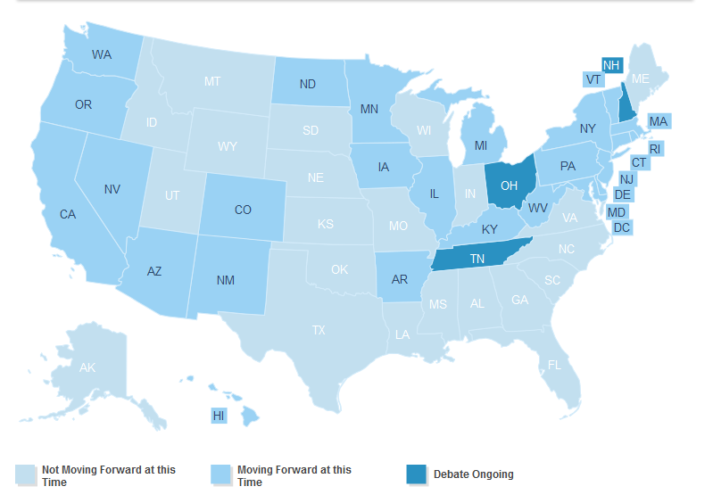

26 states and DC expanding Medicaid in 2014; 22 not expanding yet; 3 debate ongoing
Table courtesy of Kaiser Family Foundation

Useful Links

Information on the exchanges: https://www.healthcare.gov/get-covered-a-1-page-guide-to-the-health-insurance-marketplace/

CMS FAQ: http://www.cms.gov/CCIIO/Resources/Fact-Sheets-and-FAQs/

HHS ACA information: http://www.hhs.gov/healthcare/rights/index.html
Update written by: Peter Thomas, Principal; Theresa Morgan, Legislative Director and Robert Marshall, Legislative Intern; Powers, Pyles, Sutter & Verville (POWERS), PC

This update and analysis was written by Peter Thomas, Jim Pyles, Theresa Morgan, Sara Rosta, and Robert Marshall. For more information about POWERS health care reform updates, please email: Theresa.Morgan@ppsv.com

Utah is managing a small employer Exchange separate from the individual exchange operating through the FFE.

