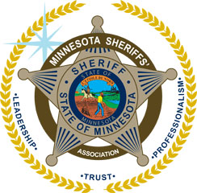
Minnesota Sheriffs' Association
Class Registration Form

Agency Name: _______________________________________________________

Billing Address: _______________________________________________________

______________________________________________________

Contact Name: _______________________________________________________

Contact Phone #: _______________________________________________________

Contact Email: _______________________________________________________
*The Contact name will receive the confirmation and invoice via email.

Please send an additional copy of the confirmation and invoice to:
Name: ________________________________________________________

Email: ________________________________________________________

TRAINING NAME: __________________________________________________

LOCATION: _______________________________________________________

TRAINING DATE(S):_______________________________________________________

If applicable, please select: am session pm session both sessions
Session Name(s): _____________________________________________________

ATTENDEE NAME & TITLE: (Please Print) AMT. DUE

- _____________________________________________________________ ___________

- ____________________________________________________________ ___________

- ____________________________________________________________ ___________

TOTAL AMOUNT DUE: ___________

Online registration available at www.mnsheriffs.org or
FAX or mail this registration form to: 651-451-8087 (Fax)

Minnesota Sheriffs' Association
100 Empire Drive Suite 222 St. Paul, MN 55103
Phone: 651-451-7216 www.mnsheriffs.org

