2017 Annual Awards Nominations
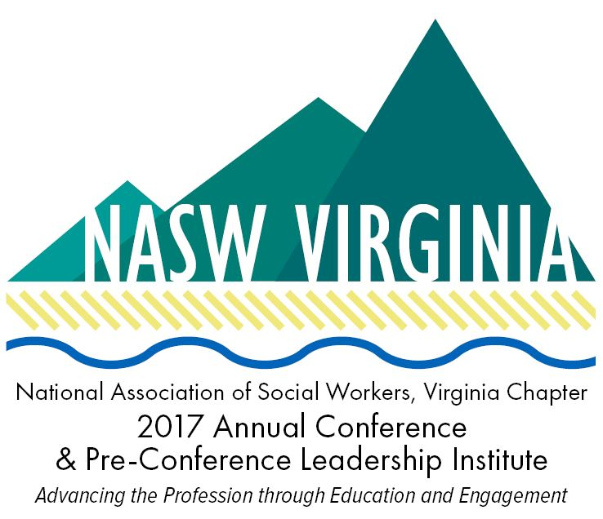

Submissions must be received by NASW-VA by February 17, 2017
at Midnight

2017 Annual Conference &
Pre-Conference Leadership Institute
to be held March 23-25

NASW Virginia honors those who are steadfast in their pursuit of professional excellence and commitment to the values of social work. NASW Virginia is looking for nominations for the 2017 Annual Conference & Pre-Conference Leadership Institute Awards Luncheon. Categories include Citizen of the Year, BSW Student of the Year, MSW Student of the Year, Social Worker of the Year, and Lifetime Achievement. If you know someone deserving of this recognition please email us at naswva@naswva.com.

2017 Social Worker of the Year Criteria
THE CANDIDATE:
• Is a social worker and member of NASW-Virginia
• Demonstrates service beyond his/her job requirements
• Takes risks to achieve results
• Has made contributions to the public’s knowledge and positive image of social
work
• Demonstrates leadership qualities
• Has made volunteer contributions
• Has made a demonstrable difference in the field of social work in areas such as:
o advocacy for clients
o impact on social policy
o exceptional practice
o program development
o administrative leadership and innovation
o noteworthy applied research
o education and publications

NOMINATION PROCEDURE
Nominate a NASW-Virginia member for Social Worker of the Year by submitting the following:
• Completed nomination form
• One-page summary which describes:
o What the social worker has accomplished
o What risks the social worker took to achieve results
o Who the beneficiaries were
• Curriculum vitae
• Letter of support

………………………………………………………………………………………………………………………………………………………………………

2017 Lifetime Achievement in Social Work Criteria
THE CANDIDATE:
• Meets all criteria for Social Worker of the Year
• Is a current or past member of NASW
• Demonstrates repeated outstanding achievements over an entire career
• Has received recognition from organizations other than professional social work organizations

NOMINATION PROCEDURE
Nominate a NASW-Virginia member for the Virginia Lifetime Achievement Award by submitting the following:
• Completed Nomination Form
• One-page summary which describes:
o What was outstanding about the nominee’s action(s)
o What risks the nominee took to achieve results
o What the nominee accomplished
o Who the beneficiaries were
o What long-term effects were achieved
• Curriculum vitae
• Letter of support

………………………………………………………………………………………………………………………………………………………………..........

2017 BSW and MSW Student of the Year Criteria
THE CANDIDATE MUST:
• Demonstrate outstanding academic work
• Demonstrate outstanding accomplishments and work in the Social Work field during an internship
• Demonstrate outstanding leadership qualities
• Be a member of NASW
• Be enrolled in a CSWE-accredited social work program in Virginia

NOMINATION PROCEDURE
Nominate a student for the Virginia BSW or MSW Student of the Year Award by submitting the following:
• Completed nomination form
• One-page minimum summary which describes the nominee’s:
o Academic achievements, leadership roles, and accomplishment in the area of social work
o Volunteer activities, academic or otherwise, that promoted a positive image of social work, benefited a population at risk, or demonstrated leadership
o Awards, scholarships, or other honors or recognition not previously mentioned
• Letter of support

………………………………………………………………………………………………………………………………………………………………..........

2017 Citizen of the Year Criteria
THE CANDIDATE:
• Cannot be member of the social work profession
• Has made contributions to the public’s knowledge and positive image of social
work
• Has made a substantial contribution which benefited the community
• Must have made specific outstanding accomplishments in the human services field
• Has personally represented ethics compatible with those defined in the NASW Code of Ethics

NOMINATION PROCEDURE
Nominate an individual for the Citizen of the Year award by submitting the following:
• Completed nomination form
• One-page summary which describes:
o What the nominee has accomplished
o What risks the nominee took to achieve results
o Who the beneficiaries were
• Letter of support
2017 Annual Awards Nomination Form

□ Lifetime Achievement
□ Social Worker of the Year
□ BSW Student of the Year
□ MSW Student of the Year
□ Citizen of the Year

NOMINEE:

NAME/TITLE

EMPLOYER OR SCHOOL

NASW MEMBERSHIP NUMBER

MAILING ADDRESS

CITY, STATE, ZIP

DAYTIME PHONE

EMAIL ADDRESS

RECOMMENDED BY:

NAME/TITLE

EMPLOYER OR SCHOOL

MAILING ADDRESS

CITY, STATE, ZIP

DAYTIME PHONE

EMAIL ADDRESS

Send nomination packet by mail, e-mail, or fax to:
NASW-VA
Attn: 2017 Annual Awards
4860 Cox Road, Suite 200
Glen Allen, VA 23060
(T) 804.204.1339
(F) 804.510.0381
(E) naswva@naswva.com

Deadline to receive nomination packet is Friday, February 17, 2017 at Midnight.
If you have any questions, please contact the Chapter Office at 804-204-1339.

